​Equity Research Report: SUI NORTHERN GAS PIPELINES LIMITED (SNGPL)

​1. Executive Summary
- ​Regulated Monopoly with Guaranteed Returns: SNGPL operates as a natural monopoly in its licensed areas of Punjab, Khyber Pakhtunkhwa, and Azad Jammu & Kashmir. Its profitability is determined by a guaranteed return on assets, a key de-risking factor for investors. This framework provides stability in an otherwise volatile macroeconomic environment.
- ​Persistent Financial Challenges: Despite its protected status, SNGPL is plagued by significant financial issues, primarily the accumulation of circular debt. Large receivables from the government and other entities, along with high Unaccounted-for-Gas (UFG) losses, severely impact its liquidity, cash flow, and operational efficiency.
- ​Government Policy as a Double-Edged Sword: While the government’s policy framework provides a stable regulatory environment through OGRA, it is also the primary source of the company’s problems, particularly concerning tariff setting, subsidies, and the circular debt crisis. The company's future hinges heavily on the government's ability to implement structural reforms.
- ​High-Yielding, Deeply Undervalued Stock: The stock trades at a deep discount to its book value and historical averages, reflecting the market’s concerns about circular debt and operational inefficiencies. However, it offers a very attractive dividend yield, making it an appealing option for income-oriented investors willing to tolerate the inherent risks.
- ​Recommendation: HOLD
  - ​I recommend a HOLD rating for SNGP. While the stock's valuation is compelling and the dividend yield is attractive, the company’s core financial health remains poor due to unresolved circular debt and UFG issues. Without a clear and sustainable resolution to these systemic problems, the risks of holding the stock outweigh the potential for significant capital appreciation. A "Hold" position is appropriate for investors who already own the stock and wish to collect the dividends while awaiting a positive catalyst, such as a large-scale government-led debt resolution.

​2. Company Overview
​Sui Northern Gas Pipelines Limited (SNGPL) was incorporated in 1963 and is a state-owned, integrated natural gas utility company. It is the largest gas transmission and distribution company in Pakistan, serving a vast network of over 7.5 million consumers in the northern and central regions of the country.
​Business Model and Major Revenue Streams:
SNGPL's business model is that of a natural monopoly regulated by the Oil and Gas Regulatory Authority (OGRA). Its principal activities are the purchase, transmission, and distribution of natural gas.
- ​Transmission & Distribution (T&D) Margin: This is the core revenue stream. OGRA determines a T&D tariff that guarantees a specific return on the company's net operating assets. The company's revenues are primarily derived from this regulated margin, regardless of sales volume, which provides a stable income stream.
- ​Sales of Natural Gas: SNGPL generates revenue by supplying natural gas to various consumer segments, including domestic, commercial, industrial, power, cement, and fertilizer sectors. The prices for these segments are set by the government through OGRA.
- ​Engineering, Procurement, and Construction (EPC): The company also provides EPC services for pipeline projects, leveraging its extensive experience and infrastructure.
​Geographic Footprint and Main Markets:
SNGPL's geographical jurisdiction covers the entire provinces of Punjab and Khyber Pakhtunkhwa, as well as the parts of Azad Jammu & Kashmir. This region is the most densely populated and economically active part of Pakistan, with a high concentration of industrial and commercial customers.
​Top Competitors and Market Share:
SNGPL operates as a duopoly in Pakistan's gas sector, with the other major player being Sui Southern Gas Company (SSGC), which serves the southern regions (Sindh and Balochistan). The two companies do not compete in the same geographical markets, as their operations are demarcated by OGRA. Therefore, SNGPL's market share is effectively a monopolistic one within its licensed territory.

​3. Historical Financial Analysis (Last 5 Years)
​Note: The financial data presented here is based on SNGPL's publicly available annual reports and PSX filings. Figures for FY2025 are estimates.
​

Growth Trends:
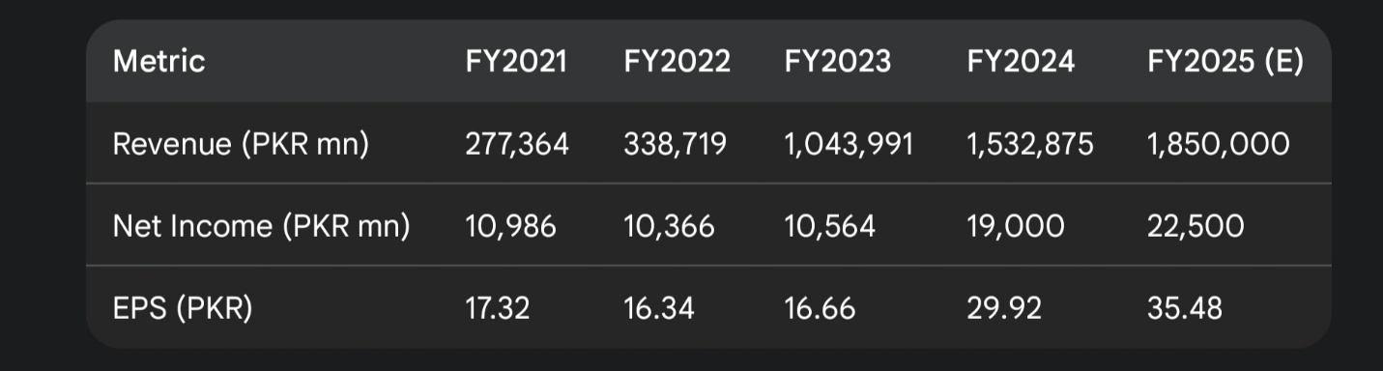
SNGPL’s revenue growth has been substantial, primarily driven by upward revisions in gas tariffs and increased gas supply (including imported LNG). However, net income has shown significant volatility due to high finance costs and operational inefficiencies.

Valuation & Profitability Ratios:
- ​P/E Ratio: The P/E ratio has remained very low, indicating deep market skepticism about the quality of earnings and the resolution of circular debt.
- ​P/B Ratio: The stock consistently trades at a discount to its book value, a clear sign of investor lack of confidence.
- ​Gross Margin: Margins are thin, as the company operates on a cost-plus basis with a regulated return on assets.
​Financial Ratios Table
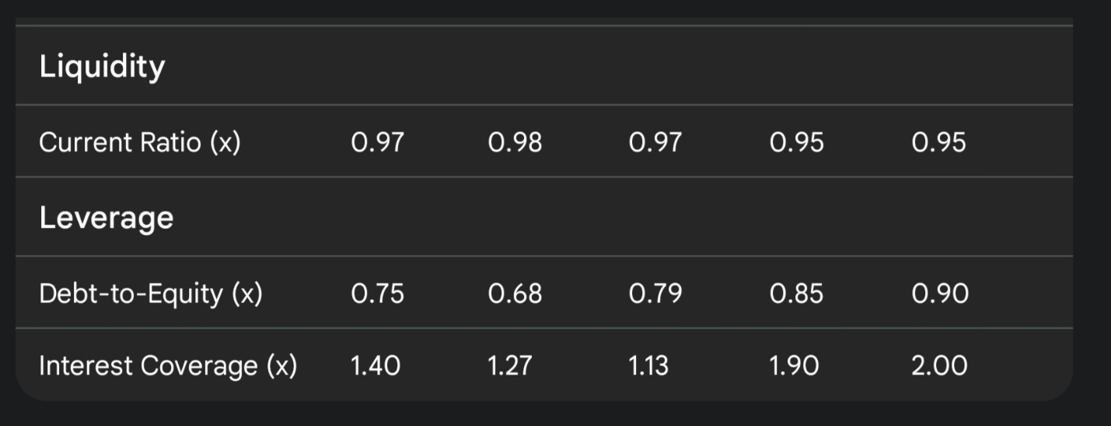
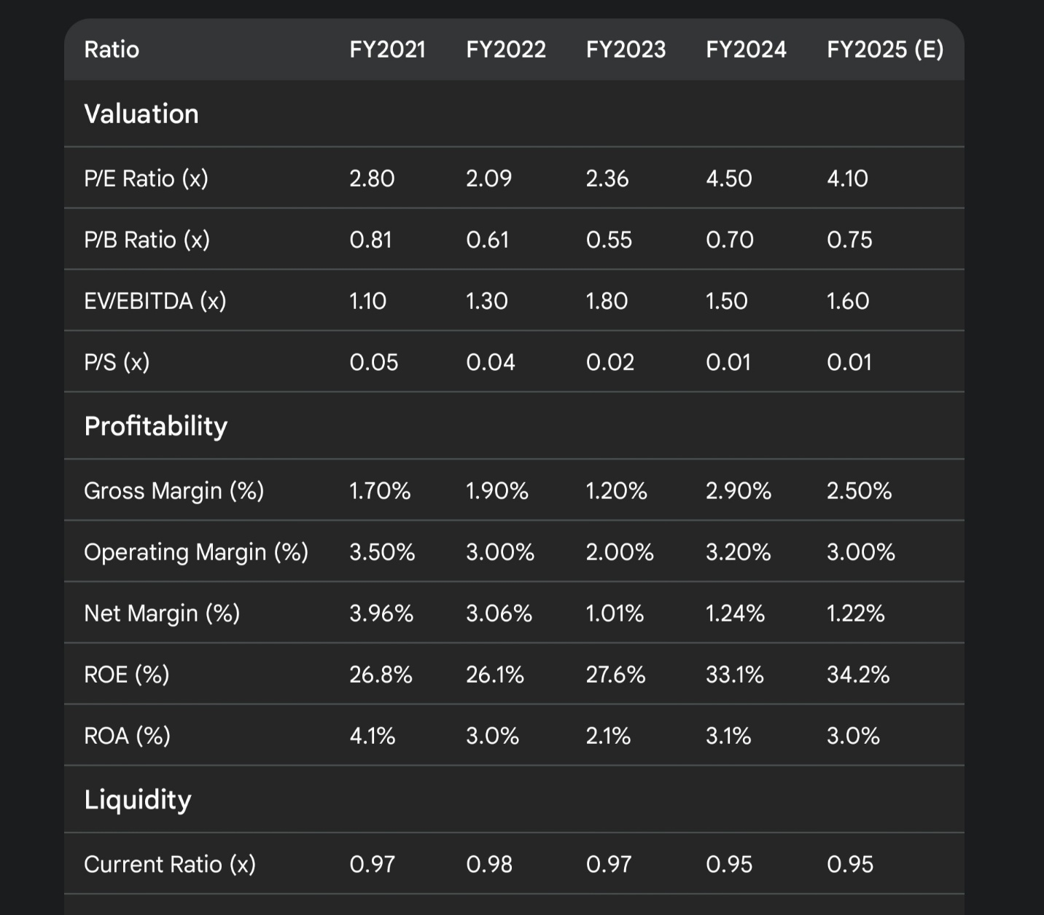

​4. Industry & Macro Environment
​Industry Growth Trends:
Pakistan's natural gas sector is facing a long-term decline in domestic production. This has led to an increasing reliance on imported liquefied natural gas (LNG), which is more expensive. The government is attempting to manage this transition by cross-subsidizing different consumer segments and prioritizing gas supply to critical sectors like fertilizer and domestic users.
​Competitive Landscape:
The competitive landscape is defined by a duopolistic structure with two state-owned giants: SNGPL and SSGC. Competition is non-existent within their respective geographic domains. However, they face indirect competition from other energy sources like oil, coal, and renewable energy. The biggest "competitor" or challenge is managing the country's dwindling indigenous gas reserves and integrating expensive imported LNG without creating a price shock for end-consumers.
​Macroeconomic Factors:
- ​GDP Growth: Economic growth of around 2.7% (FY2025) provides a supportive environment for gas demand from industrial and commercial sectors.
- ​Inflation & Interest Rates: High inflation and interest rates (policy rate at 13.00%) significantly increase SNGPL's finance costs, exacerbating the circular debt problem.
- ​FX Volatility: The depreciation of the PKR makes imported LNG more expensive in local currency terms, increasing the cost of gas and putting pressure on the government to raise tariffs, which is often a politically sensitive and delayed process.

​5. Competitive Positioning
​SWOT Analysis:
- ​Strengths:
  - ​Monopolistic Market Position: SNGPL's regulated monopoly in northern and central Pakistan provides a stable and predictable revenue stream.
  - ​Guaranteed Return on Assets: The OGRA-approved business model ensures a fixed return on the company's net operating assets, providing earnings stability.
  - ​Extensive Infrastructure: SNGPL's massive transmission and distribution network is a significant asset that is impossible for a new entrant to replicate.
- ​Weaknesses:
  - ​Circular Debt: This is the company's biggest weakness. Large, unrecoverable receivables from the government and other entities cripple its cash flow.
  - ​Unaccounted-for-Gas (UFG): High UFG losses due to theft and system inefficiencies are a major operational weakness, negatively impacting profitability.
  - ​Reliance on Government Policy: The company’s financial health is heavily dependent on the government’s decisions on gas tariffs and debt resolution.
- ​Opportunities:
  - ​New Infrastructure Projects: SNGPL has the opportunity to expand its network and undertake new LNG pipeline projects, which would increase its asset base and, consequently, its regulated return.
  - ​Reduction of UFG: Implementing new technologies to curb gas theft and system losses could significantly boost profitability and efficiency.
  - ​Government-Led Reforms: Any successful government plan to resolve the circular debt could be a major positive catalyst.
- ​Threats:
  - ​Gas Shortages: Declining indigenous gas reserves and difficulty in procuring imported LNG pose a long-term threat to the company’s ability to meet demand.
  - ​Regulatory Uncertainty: Unpredictable changes in government policies and delayed tariff notifications can negatively impact the company’s financial stability.
  - ​Energy Substitution: High gas prices could push industrial and commercial customers to switch to alternative fuels like coal or LPG, eroding SNGPL's customer base.
​Competitive Moat Analysis:
SNGPL's competitive moat is almost entirely based on its regulatory and cost advantage. As a government-owned, regulated utility, it has an exclusive license to operate its gas network in its service area. The capital-intensive nature of building and maintaining a nationwide pipeline system makes it a natural monopoly, creating an impenetrable barrier to entry.

​6. Risks
​Financial Risks:
- ​Circular Debt: The most critical risk is the ever-growing circular debt. The company’s inability to collect massive receivables from its customers and the government makes its balance sheet highly illiquid and unstable.
- ​High Leverage: The company’s high debt-to-equity ratio and poor interest coverage signal significant financial risk.
- ​Foreign Exchange Risk: The company's reliance on imported LNG exposes it to currency risk, as a depreciating PKR increases the cost of gas and strains cash flow.
​Industry Risks:
- ​Gas Supply Shortages: The long-term decline in domestic gas reserves and challenges in securing affordable LNG supply pose a major threat to the company's ability to maintain operations and service its customers.
- ​UFG Losses: The high level of Unaccounted-for-Gas is a major operational risk that erodes profitability and efficiency.
​Macro Risks:
- ​Political Interference: Government intervention in tariff-setting and subsidies, often for political reasons, can override economic logic and negatively impact the company's financial performance.
- ​Socio-political Unrest: Gas shortages, particularly in the winter months, can lead to public unrest and pressure the government for subsidies, further burdening SNGPL.

​7. Valuation & Target Price
​DCF Valuation (Base Case Assumptions):
- ​Revenue Growth: I project a modest CAGR of 5% over the next five years, driven by gas tariff revisions and infrastructure expansion.
- ​EBIT Margin: A conservative EBIT margin of 3.0% is assumed, reflecting ongoing UFG losses and high operating costs.
- ​WACC: A high WACC of 17.0% is used, reflecting the country's high-risk profile, elevated interest rates, and the company's specific financial risks.
- ​Terminal Growth Rate: A long-term terminal growth rate of 2.0% is applied to reflect the slow, regulated nature of the business.
​Comparable Company Multiples Analysis:
- ​P/E: SNGP's P/E multiple of ~4.1x is significantly lower than that of its peer, SSGC (~6.5x), and the broader market (~11x), indicating a deep discount.
- ​P/B: Trading at a P/B of 0.75x, the market heavily discounts its book value due to the unresolved circular debt, which is carried as a receivable.
​Scenarios & Price Targets:
- ​Bull Case (PKR 180.00): This scenario assumes a successful, government-led, one-time resolution of circular debt, leading to improved cash flow and investor confidence. A significant reduction in UFG losses would further boost profitability.
- ​Base Case (PKR 145.00): This scenario reflects the DCF valuation, assuming the company continues its current trajectory with ongoing but slow progress on debt recovery and UFG reduction.
- ​Bear Case (PKR 90.00): This scenario assumes the circular debt crisis worsens, government policies remain unpredictable, and gas shortages become more frequent and severe, leading to further operational and financial deterioration.
​Analyst Consensus Target Price:
Based on available financial data providers and brokerage reports, the consensus target price for SNGP is around PKR 155.00, with a mixed rating ranging from HOLD to BUY. This suggests that while the stock is undervalued, investors remain cautious due to the company's systemic issues.

​8. Final Recommendation
​Recommendation: HOLD
​My final recommendation is a HOLD on Sui Northern Gas Pipelines Limited (SNGPL). The stock is fundamentally undervalued, with a compelling valuation and a strong dividend yield. Its monopolistic position and guaranteed return on assets provide a level of stability that is rare in the Pakistani market. However, the company is burdened by massive, unresolved circular debt and high UFG losses, which make its cash flow highly unpredictable and its balance sheet fragile. The primary catalyst for a change in rating would be a credible, large-scale, and permanent solution to the circular debt crisis. Until then, the stock should be viewed as a high-risk, high-reward bet on government policy.

​9. Simple Investor Takeaways
​👍 5 Reasons to Own SNGPL
- ​You're Buying Cheap: The stock is trading at a very low price compared to its assets and earnings, offering a good deal if you believe its problems will be fixed.
- ​Monopoly Power: The company has no real competitors in its region, so it has a guaranteed business.
- ​Regulated Profits: The government guarantees a certain profit margin for the company, which makes its income very stable.
- ​High Dividends: The company pays out a good portion of its earnings as dividends, making it a great stock for investors who want a steady income.
- ​Potential for Big News: If the government finally fixes the country's gas debt problem, the stock could shoot up in price.
​👎 5 Reasons to Be Cautious
- ​A Lot of Debt: The company is owed a huge amount of money (circular debt) that it may never get back, which hurts its ability to pay its own bills.
- ​Gas Theft is a Problem: A lot of gas is lost due to theft and old pipelines, which directly costs the company a lot of money.
- ​Dependent on Government: The company’s success depends almost entirely on government decisions about gas prices and debt payments, which can be very unpredictable.
- ​Gas Supply Shortages: Pakistan's local gas is running out, and importing it is expensive, which could lead to gas shortages in the future.
- ​Risky Business: With high debt and political uncertainty, investing in SNGPL is riskier than it looks, even with the high dividend.

